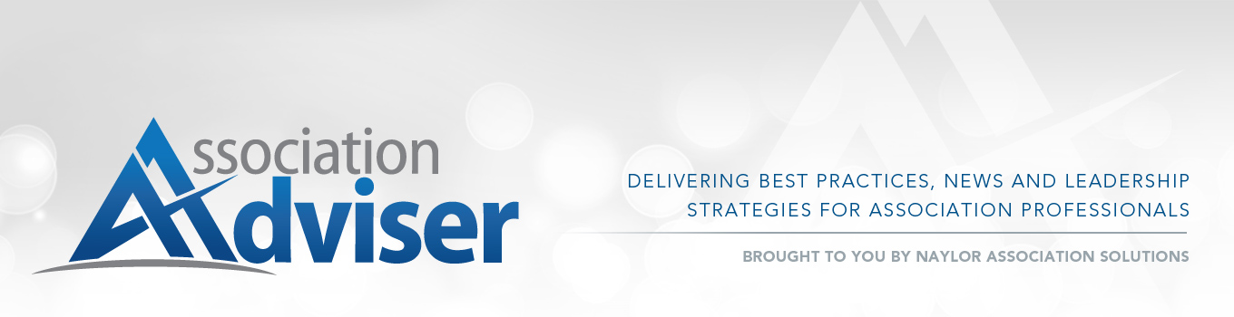Webinar Q&A: Taking Aim at Association Communications

Q: Do you recommend that subgroups of society have their own Twitter accounts?
A: Having subgroups could work very well and provide targeted messaging and a great sense of community to members of those groups. If you’re considering this option, have your communications team focus on the subgroups and facilitate information crossover by retweeting to all groups, which gives the mainstream member a taste of what everyone is saying (and an opportunity to get more involved).

Q: You’ve talked a lot about engagement. Do you have any specific stats on what you can do to improve engagement at your association?
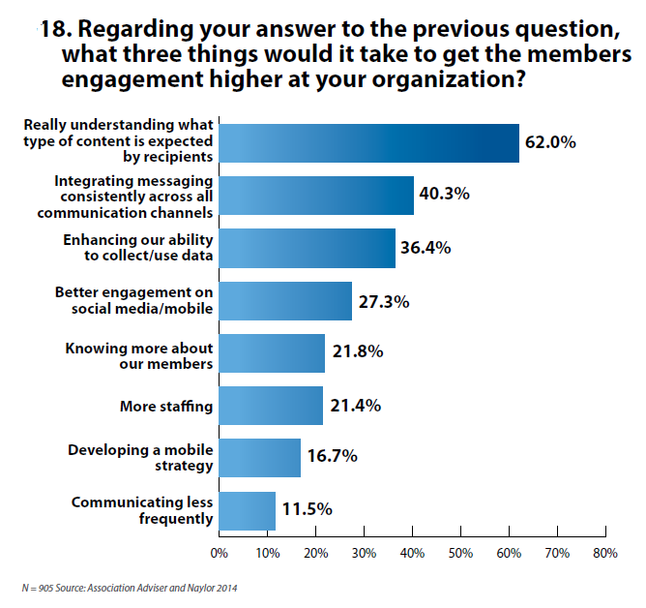
A: As you can see from the following graph, respondents to the 2014 Association Communications Benchmarking Study cited the importance of understanding what type of content is most important as a key factor for increasing engagement with the association’s communications.

When asked how they determine the type of content that is most important, a combination of traditional and new tactics was indicated, with the largest percentage (76 percent) citing face-to-face interaction.
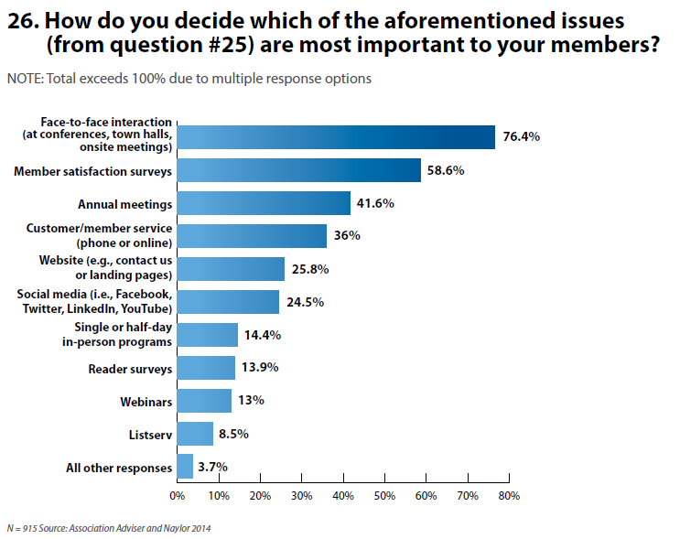
Q: You mentioned small associations often don’t have enough staff to customize their content…any idea how small associations compare to larger associations?
A: See chart below
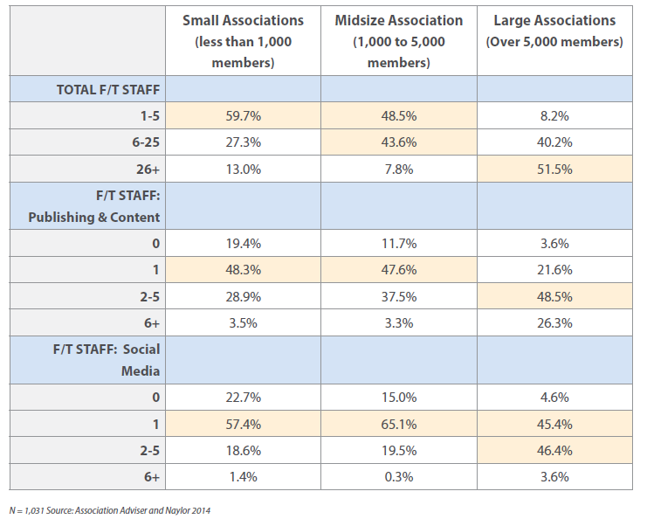

Q: If Naylor does our advertising sales, do they conduct an annual advertiser survey? If yes, how can we access it?
A: Yes, Naylor conducts advertiser surveys on behalf of our clients. Please talk to your Naylor contact for more details specific to your organization.
Q: What's your recommendation regarding open-access vs. members-only content, both online and in print?
A: With the abundance of free information that is available to members through a quick Google search, associations would be ill-advised to gate all of their content. As you can see from the chart below, about two-thirds of associations (67.6 percent) restrict at least half of their communications to members only—with 36 percent of associations designating most of their communications for members.
It’s important to leverage content in such a way that gives your potential members a taste of what they would receive if they joined, and then make sure you are providing plenty of opportunity for prospective members to join by providing direct calls-to-action and links in both print and online media. Remember: An association’s biggest asset isn’t their content, it’s their members; but great content is one of many tools associations have at their disposal to become their industry’s most valued resource.
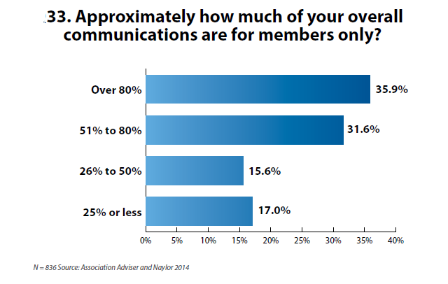

Q: What's the role of print communications in the future? We're seeing some pushback on electronic communication because of overload, thus have added back some print materials.
A: This is great news! Print is not dead and has a completely different value in the association world. Your membership magazine provides a tangible benefit with information directed specifically to the association member. That is a completely different proposition than what we’ve seen with newspapers and other commercial media. As this graph shows, associations ranked the value of their print magazine 4.2 on scale of 0–5. [Download the full report here.]
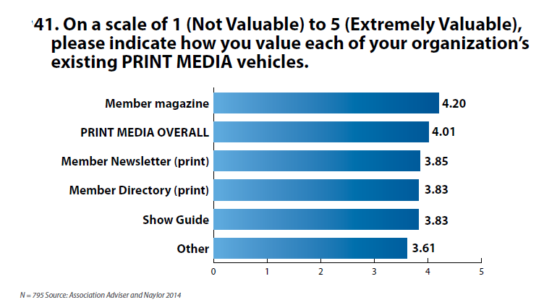
Digital media has handed us this “communication overload” conundrum. We want things to be easier, but give us too much clutter, and we tune out everything, even the things we originally signed up to receive. Keep pushing the print. Even a good-old postcard does the trick if your primary goal is to get someone’s attention.

Q: Where can we find stats on the effectiveness of snail mail for those of us trying to convince the boss to stop relying 100 percent on email?
A: Great question. This is an area that we will explore further in the 2015 Association Communications Benchmarking Report. In the meantime, you might find some useful stats at theDMA.org.

Q: Any tips for newsletter/email content not reaching members who use Gmail [or other third-party email service providers]? If we use an emailing service like Constant Contact® or MailChimp® the communications are syphoned into the "Promotions" black-hole tab... it is pretty hard to avoid using these systems, as we have over 10,000 email contacts stored.
A: We advise our clients to use contemporary “common sense” tactics to help with email/eNewsletter deliverability, while we provide back-end coverage to ensure the best possible results. For example:

Be consistent in your frequency/distribution so members know when to expect incoming communications.
- Ensure content is relevant so members want to find it in their in-boxes.
- Avoid using tactics that tend to alert spam filters: words like “money,” “free,” “sale;” excessive use of punctuation, and too many/repetitive links.
- Utilize a non-email channel, such as direct mail or phone, to let folks know how to move your association’s messages to their Primary inbox: drag an association email from the Promotions tab into the Primary tab, then click “Yes” when Gmail asks you if you want to do that for all messages from that sender.

Q: Is there any information available as to what social media platform professionals engage on versus what students and emerging professionals engage on?
A: As the chart below shows, listservs, Facebook, Twitter and LinkedIn are respondents’ most highly valued forms of social media from last year’s benchmarking survey. This video from Association Adviser TV provides three tips for communicating with the younger generation.
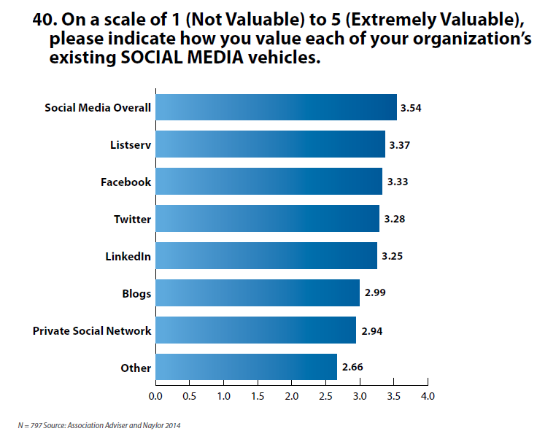
Q: The principles you talked about in today’s webinar are great, but how can we best implement them?
A: Determining the best path to implementation is going to vary by organization. Utilizing the “Take AIM” approach is an on-going process that requires buy-in at all levels of the organization. To discuss specific ideas for implementing this at your association, contact Jill Andreu at Naylor.

FOR MORE INFORMATION ABOUT ASSOCIATION ADVISER OR NAYLOR ASSOCIATION SOLUTIONS, PLEASE VISIT OUR WEBSITES. CLICK HERE TO DOWNLOAD THE FULL 2014 ASSOCIATION COMMUNICATIONS BENCHMARKING REPORT.

